A1353. PAC-Poly-HI-Necker Island-Ki’i Figure-Vesicular Basalt-1000 CE

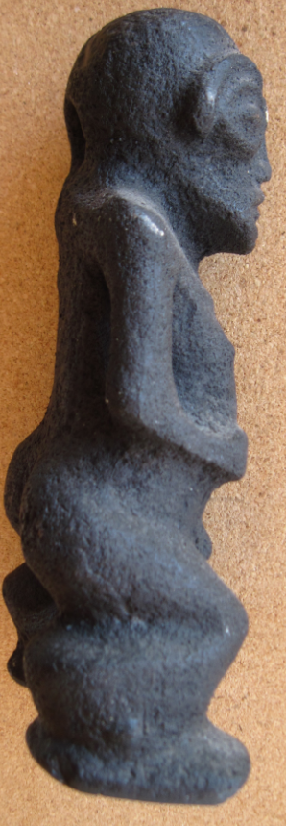 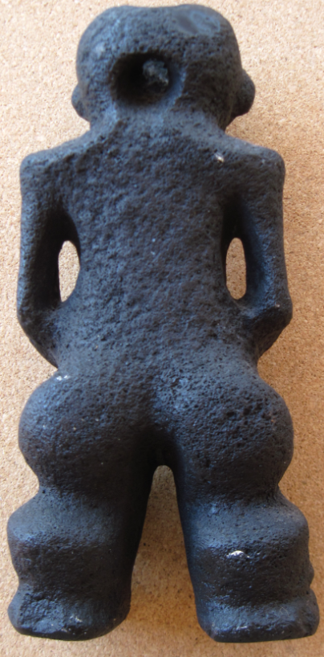 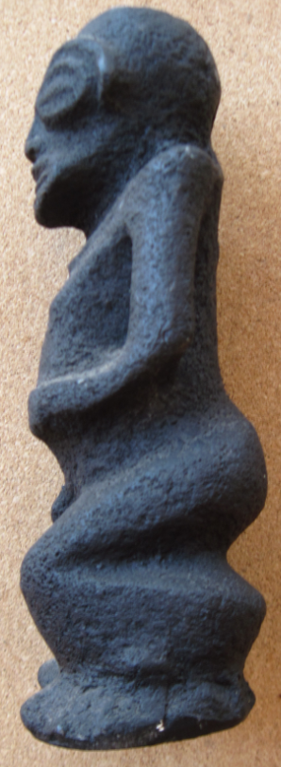 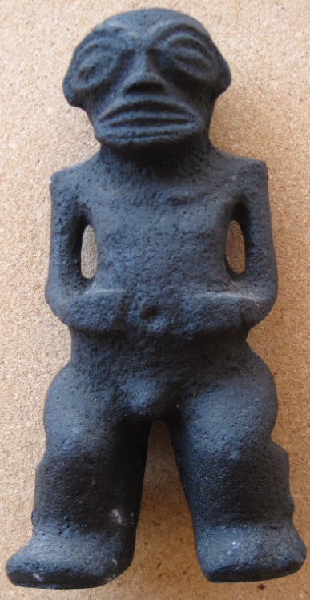

Figs. 1-4. Necker Island-Ki’i Figure-Vesicular Basalt-1000 CE

**Case no.:**

**Accession Number:**

**Formal Label:** Necker Island-Ki’i Figure-Vesicular Basalt-1000 CE

**Display Description:**

Necker Island or Mokumanamana is a barren, highly weathered, volcanic extrusion 300 miles from the big island of Hawaii that was active some thousands of years in the past. Exploring Polynesians from the Marquesas archipelago were the first to land on this rock mass c 650-800 CE, and here they established 33 rudimentary ceremonial platforms (*heiau or morai*) in thankfulness of finding an island in the vastness of the Pacific. They also carved several small anthropomorphic figures *ki’i* such as this one with the characteristic almond–shaped eyes in the Marquesas style. Spiritual beliefs centered on the concept of the umbilical cord (*ʻaha*) as a symbolic connection between ancestors and descendants, and the *‘aha* became a widespread organizing principle of Hawaiian social life. This *ki’i* displays its missing umbilical cord by placing both hands on either side of its inverted navel.

According to myths and legends of the people of Kaua'i, which lies to the southeast, Necker Island was the last known refuge for a race of mythical "little people" called the Menehune who settled on Necker after being chased off Kaua'i by the Polynesians. It is believed that the Menehune built the 33 ceremonial stone platforms (*heiau or morai*) and their attendant *ki’i*.

Visits to the island are said to have started c 1000 CE. Necker Island was unknown to Europeans when La Perouse sailed within a third of a league of the island on his passage westward on November 4, 1786. He noted its perpendicular cliffs, the absence of trees, and the violence of the sea, which made it impossible to land. He called it Ile Necker, in honor of Monsieur Jacques Necker, French Minister of Finance under Louis XVI.

John Turnbull, who visited the Hawaiian Islands, December 17, 1802 to January 21, 1803, on the British ship Margaret, mentioned two native Hawaiians, who had been engaged to dive for pearls on a reef on Necker, and had their curiosity aroused by a "range of stones, placed with some regularity in the manner of a wall, and about three feet high" which was one of the 33 *heiau* on the island. Then, in 1894, Captain J. A. King and his crew were sent by the Provisional Hawaiian Government to annex the island and the crew recorded stone platforms with upright stones and *ki‘i*, or vesicular basalt figures like this one, some of which they collected.

Based on recent research from 2010-2012 (Kikiloi 2012), we now know that over a four-hundred-year period from approximately 1400-1815, Necker Island had become the central focus of chiefly élites who established this island as the ritual center for the Hawaiian system of *heiaus* or *morais*. These efforts integrated chiefs and priests into a single social class called the *ali’i*, developed a charter for institutional order, and sponsored a comprehensive religious system that became widely accepted throughout the main Hawaiian Islands. Through commemorative rituals, northwest (that is in the direction of the island of Necker) was acknowledged and reaffirmed as the primary trajectory of social power where élite status of the *ali’i’s* authority, and spiritual power of *mana* had originated and had been legitimized over the centuries.

**LC Classification:**  [GN670](http://librarycatalog.unh.edu/search~S5?/fGN670+.B43/fgn++670+b43/-3,-1,,B/browse)

**Date or Time Horizon:** 1000 CE

**Geographical Area:** Leeward Hawai’ian Islands

**Map:**

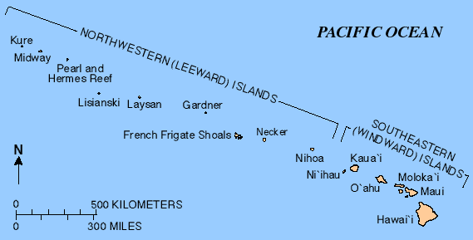

Fig. 5. Leeward Hawai’ian Islands **After https://upload.wikimedia.org/wikipedia/commons/b/b6/Hawaiianislandchain_USGS.png**

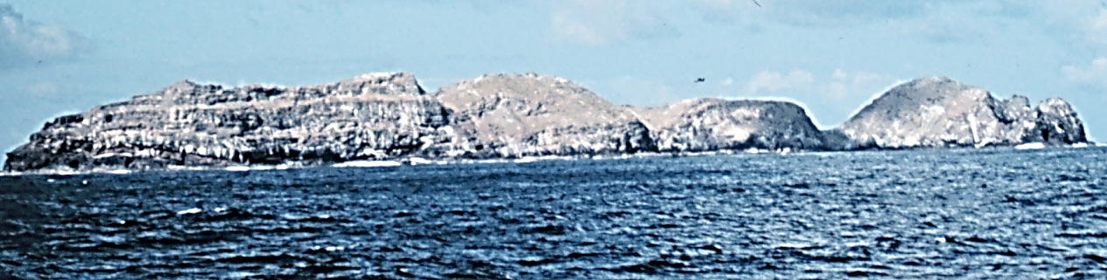

Fig. 6. **Necker Island. After** [**https://upload.wikimedia.org/wikipedia/commons/e/e5/Necker_Island_1969.jpg**](https://upload.wikimedia.org/wikipedia/commons/e/e5/Necker_Island_1969.jpg)

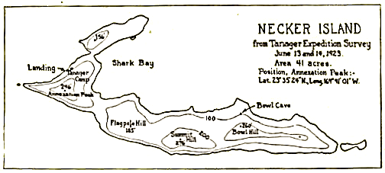

Fig. 7. **Map of Necker Island. After http://www.janeresture.com/necker/necker.jpg**

**GPS coordinates:**  [23°34′35″N 164°42′0″W](https://tools.wmflabs.org/geohack/geohack.php?pagename=Necker_Island_(Hawaii)&params=23_34_35_N_164_42_0_W_region:US-HI_type:isle)

**Cultural Affiliation:** Polynesian

**Medium:** vesicular basalt

**Dimensions:** H 7 in

**Weight:**

**Condition: museum replica**

**Provenance:** B. P. Bishop Museum, 1965

**Discussion:**

Necker Island’s anthropomorphic figures or *ki’i* are very similar stylistically to those anthropomorphic figures from the Marquesas archipelago. They are associated with those placed on ceremonial platforms (*heiau or morai*) found on Necker Island and in more developed versions in the Hawai’ian archipelago, especially on the big island.

Settlement on Kealakekua Bay has a long history. *Hikiau Heiau* was a *luakini* temple where human and animal blood sacrifices were offered. It is believed that *luakini heiaus* were first instituted by [Paʻao](https://en.wikipedia.org/wiki/Pa%CA%BBao), a high priest from Kahiki, specifically from "Wewaʻu" and "'Uporu," Tahitian places. It is also believed that he owned *ahu’pua’a* (land segments) in both Tonga and Samoa. He is credited with establishing many of the religious and social institutions of fifteenth century Hawai’i.

At the south end of Kealakekua Bay bay, at coordinates [19°28′31″N 155°55′9″W](https://tools.wmflabs.org/geohack/geohack.php?pagename=Kealakekua_Bay&params=19_28_31_N_155_55_9_W_type:landmark_region:US-HI&title=Hikiau+Heiau), associated with funeral rites, a large platform of volcanic boulders was originally over 16 feet (4.9 m) high, 250 feet (76 m) long, and 100 feet (30 m) wide (Van James 1995t: 94). The sheer cliff face called *Pali Kapu O Keōua* overlooking the bay was the burial place of Hawaiian royalty. The name means "forbidden cliffs of Keōua "in honor of [Keōua Nui](https://en.wikipedia.org/wiki/Keoua_Nui), (died c. 1750–1770) an Hawai’ian *ali’i* and father of Kamehameha I, the first King of united Hawaiʻi. He was sometimes known as the "father of kings" since many rulers were his descendants. The difficulty in accessing the cliff kept the exact burial places secret.

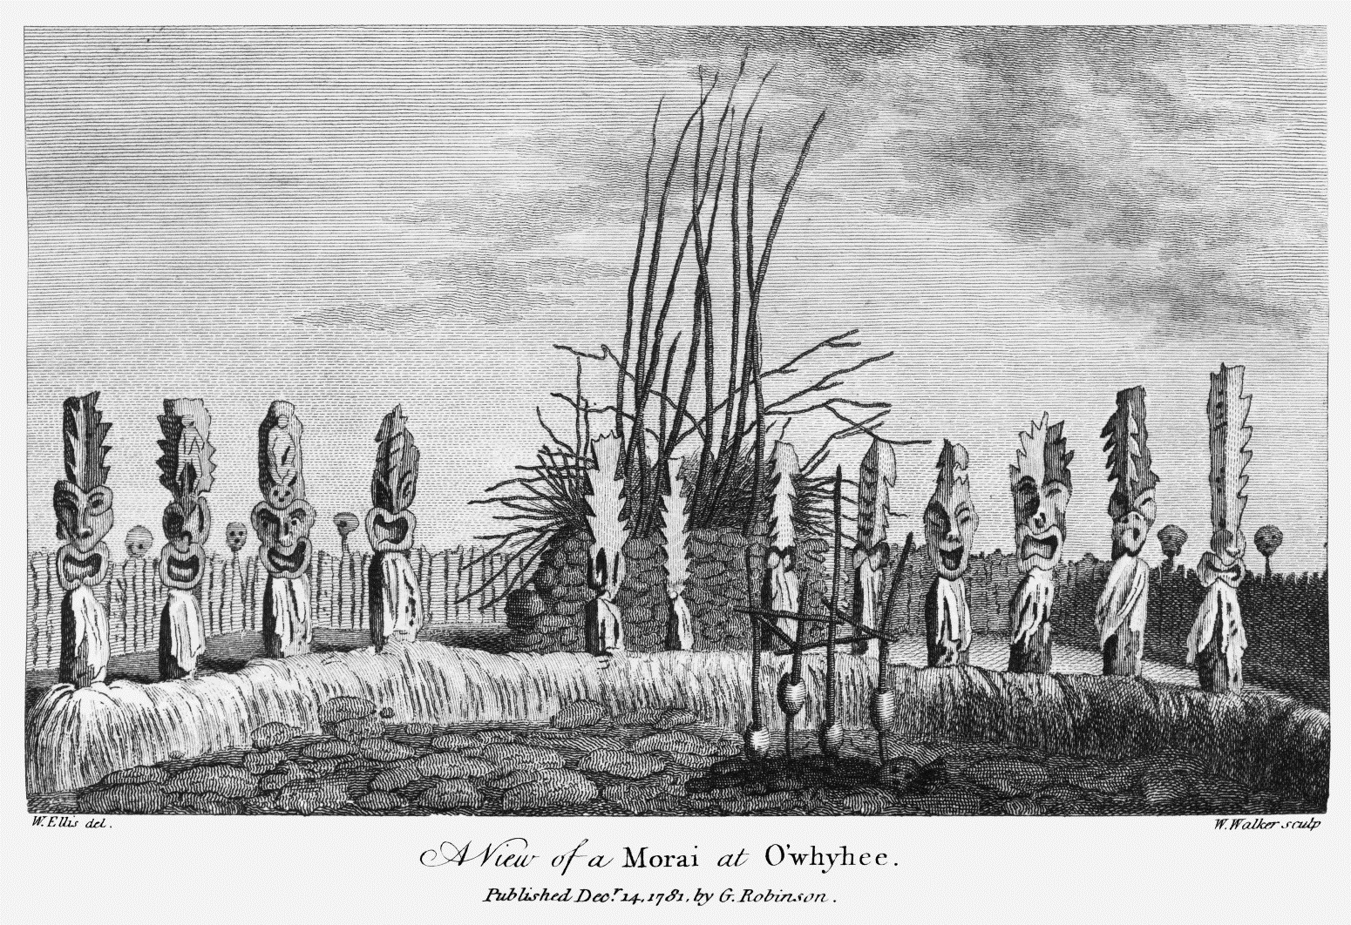

Fig. 8. An illustration by William Ellis of the *morai ([heiau](https://en.wikipedia.org/wiki/heiau" \o "w:heiau))* at [Kealakekua Bay](https://en.wikipedia.org/wiki/Kealakekua_Bay) on Hawai'i. Engraved by W. Walker after Ellis (Ellis 1782, II f, p. 180).

The village of *Kaʻawaloa* was at the north end of the bay in ancient times, where the *Puhina O Lono Heiau* was built, along with some royal residences. The name of the village means "the distant Kava", from the medicinal plant used in religious rituals. The name of the bay comes from *ke ala ke kua* in the Hawaiian Language which means "the Lono’s pathway" (Soehren, 2010). This area was the focus of extensive *Makahiki* celebrations in honor of the god *Lonoikamakahiki*, a holiday that covered four consecutive lunar months, approximately from October or November through February or March. The focus of this season was a time for men, women and chiefs to rest, strengthen the body, and have great feasts of commemoration (*‘aha’aina ho’omana’o*). During Makahiki season labor was prohibited and there were days for resting and feasting. The Hawaiians gave thanks to the god *Lonoikamakahiki* for his care. He brought life, blessings, peace and victory to the land. They also prayed to the gods for the death of their enemies. Maka’ainana (commoners) prayed that *ahu’pua’a* lands of their *ali’i* (chief) may be increased, and that their own physical health along with the health of their chiefs be at the fullest Another name for the area north of the bay was *hale ki'i*, due to the large number of wood carvings, better known today as "*tiki*" deposited there (Soehren, 2010).

**References:**

Anon. 2016. “Islands of Mystery: The Archaeology of Nihoa and Mokumanamana,” *Ka ‘Elele*, Summer.

Ellis, William. 1782. *An authentic narrative of a voyage : performed by Captain Cook and Captain Clerke, in His Majesty's ships Resolution and Discovery during the years 1776, 1777, 1778, 1779, and 1780 ; in search of a north-west passage between the continents of Asia and America, including a faithful account of all their discoveries, and the unfortunate death of Captain Cook*. London: G. Robinson.

Kikiloi, Kekuewa Scott T. 2012. “Kūkulu Manamana: Ritual power and religious expansion in Hawai`i The ethno-historical and archaeological study of Mokumanamana and Nihoa Islands.” Ph.D. University of Hawai'i at Manoa.

Soehren, Lloyd J. 2010. Hawaiian Place Names. Ulukau, the Hawaiian Electronic Library. Retrieved Apr 12 2018.

Van James, *Ancient Sites of Hawaiʻi*, 1995, Honolulu: Mutual Publishing.